**1. WAP to convert temperature from degree Celsius to Fahrenheit.**

#include <stdio.h>

#include <conio.h>

int main()

{

float celsius,fahrenheit;

printf("Enter the temperature in celsius: ");

scanf("%f",&celsius);

fahrenheit=celsius*1.8+32;

printf("%.3f Celsius is %.3f Fahrenheit",celsius,fahrenheit);

return 0;

}

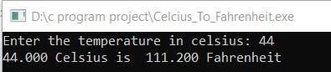

**2. WAP to rotate bits of a number.**

#include <stdio.h>

#include <conio.h>

int main()

{

int r,n=7;

printf("Enter rotation of number %d: ",n);

scanf("%d",&r);

printf("\nRotation is %d times\n",r);

printf("\nLeft rotation of number %d is %d",n,n<<r);

printf("\nRight rotation of number %d is %d",n,n>>r);

return 0;

}

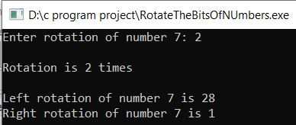

**3. WAP to check leap year using conditional operator.**

#include<stdio.h>

#include <conio.h>

int main()

{

int year;

printf("\nEnter the year: ");

scanf("%d",&year);

if( year%100!=0 && year%4==0 || year%400==0 )

{

printf("\n%d, year is Leap year ",year);

}

else

{

printf("\n%d, year is not leap year ",year);

}

return 0;

}

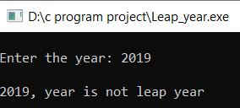

**4. WAP to demonstrate union.**

#include <stdio.h>

#include <conio.h>

union student

{

char name[50];

int id;

}stu;

int main()

{

printf("Enter id of student: ");

scanf("%d",&stu.id);

printf("Enter name of student: ");

scanf("%s",&stu.name);

printf("\n***Record of student is***: \n");

printf("Student id: %d\n",stu.id);

printf("Student name is : %s ",stu.name);

return 0;

}

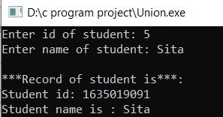

**5. WAP to find LCM of two numbers.**

#include <stdio.h>

#include <conio.h>

int main()

{

int a,b,LCM,c=1,i=0;

printf("Enter two numbers: ");

scanf("%d%d",&a,&b);

for(i=0;i<a*b;i++)

{

if(c%a==0 && c%b==0)

{

LCM=c;

break;

}

c++;

}

printf("LCM of %d and %d is %d number ",a,b,LCM);

return 0;

}

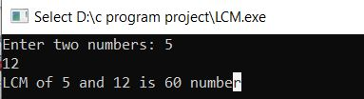

**6. WAP to find all roots of quadratic equation using switch case.**

#include <stdio.h>

#include <conio.h>

int main()

{

int a,b,c,dis;

printf("\nEnter first co-efficient of x (ax^2): ");

scanf("%d",&a);

printf("\nEnter second co-efficient of x (bx): ");

scanf("%d",&b);

printf("\nEnter third number of c: ");

scanf("%d",&c);

dis=b*b-4*a*c;

switch(dis)

{

case 0:

printf(" %d is Equal number ",dis);

break;

default:

if(dis<0)

{

printf("%d is Imaginary",dis);

}

else if(dis>0)

{

printf("%d is Greater and unequal ",dis);

}

break;

}

return 0;

}

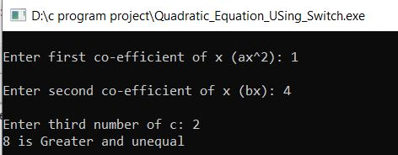

**7. WAP to print plus star pattern series using for loop.**

#include <stdio.h>

#include <conio.h>

int main()

{

int i,j,n=8;

printf("Plus Star pattern is shown below \n\n");

for(i=0;i<n;i++)

{

for(j=0;j<n;j++)

{

if(i==n/2 || j==n-1)

{

printf("**");

}

else

{

printf(" ");

}

}

printf("\n");

}

return 0;

}

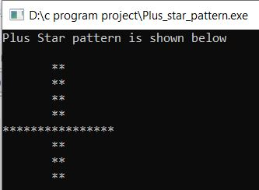

**8. WAP to input elements in array & find frequency of each element in array.**

#include <stdio.h>

#include <conio.h>

#include <stdlib.h>

int main()

{

int size=5;

int num[size],count=0,j=0,i=0,frequency[size];

printf("Enter the numbers to know frequency of each number: ");

for(i=0;i<size;i++)

{

scanf("%d",&num[i]);

frequency[i]=-1;

}

for(i=0;i<size;i++)

{

count=1;

for(j=i+1;j<size;j++)

{

if(num[i]==num[j])

{

count++;

frequency[j]=0;

}

if(frequency[i]!=0)

{

frequency[i]=count;

}

}

}

for(i=0;i<size;i++)

{

if(frequency[i]!=0)

{

printf("\n%d repeated %d times \n",num[i],frequency[i]);

}

}

return 0;

}

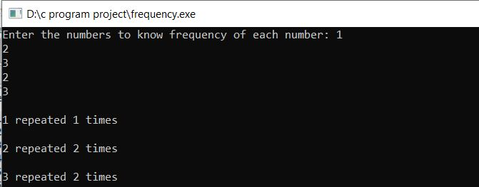

**9. WAP to find and replace a word in file.**

#include <stdio.h>

#include <string.h>

#include <stdlib.h>

int main()

{

FILE *fp,*fp2;

char word[150],replace[150],ch,read[150];

fp=fopen("Cprogramming.txt","r");

fp2=fopen("Cdefination.txt","w+");

if(fp==NULL || fp2==NULL)

{

printf("Can't open file ");

exit(0);

}

printf("The content of file is shown below \n");

while(1)

{

ch=fgetc(fp);

if(ch==EOF)

{

break;

}

printf("%c",ch);

}

printf("\n\nEnter the word to find: ");

fgets(word,150,stdin);

word[strlen(word)-1]=word[strlen(word)];

printf("Enter the word to replace it with : ");

fgets(replace,150,stdin);

replace[strlen(replace)-1]=replace[strlen(replace)];

fprintf(fp2,"%s -%s \n ",word,replace);

rewind(fp);

while(!feof(fp))

{

fscanf(fp,"%s",read);

if(strcmp(read,word)==0)

{

strcpy(read,replace);

}

fprintf(fp2,"%s ",read);

}

rewind(fp2);

while(1)

{

ch=fgetc(fp2);

if(ch==EOF)

{

break;

}

printf("%c",ch);

}

fclose(fp);

fclose(fp2);

return 0;

}

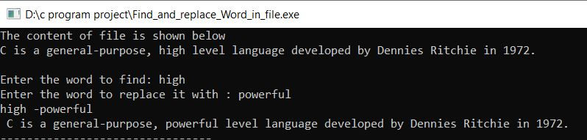

**10. WAP to read element in a matrix & check whether matrix is an identity matrix or not.**

#include <stdio.h>

#include <conio.h>

int main()

{

int i,j,n=2;

int a[n][n],flag=1;

printf("Enter the elements of Matrix 'A': ");

for(i=0;i<n;i++)

{

for(j=0;j<n;j++)

{

scanf("%d",&a[i][j]);

}

}

printf("\n\nMatrix A is shown below: \n");

for(i=0;i<n;i++)

{

for(j=0;j<n;j++)

{

printf("%d\t",a[i][j]);

}

printf("\n");

}

for(i=0;i<n;i++){

for(j=0;j<n;j++)

{

if(a[i][j]!=1 && a[j][i]!=0)

{

flag=0;

break;

}

}

}

if(flag==1){

printf("\nIt is identity Matrix ");

]

}

else

{

printf("\nIt is not identity Matrix ");

}

return 0;

}

